1. whoami 🡪 Display the usename

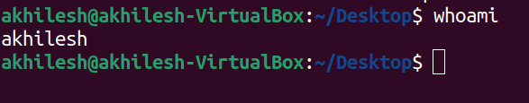

2. hostname 🡪 Displays the hostname



3. ls 🡪 Displays the list of directories

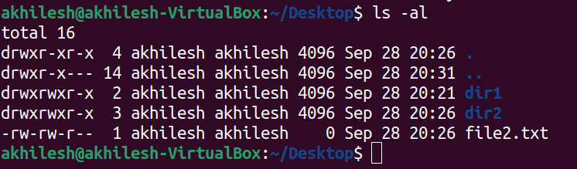

4. ls -la 🡪 Displays the list of directories including hidden files and other details



5. pwd 🡪 Displays the current working directory

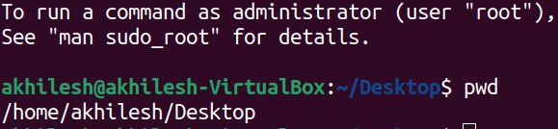

6. cd <dir name> 🡪 To access the directory

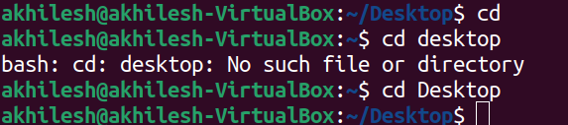

7. cd .. 🡪 To go back to the previous directory

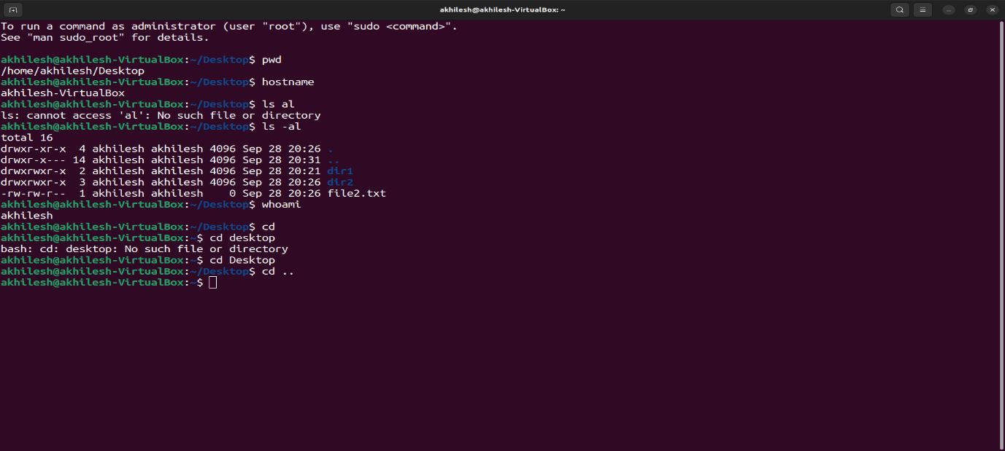

8 . touch <filename> 🡪 To create a file



9. vi/nano <filename> 🡪 Creates a file and open in write mode

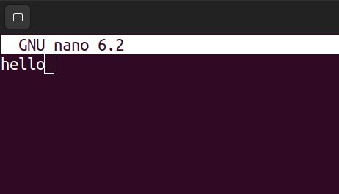



10. cat <filename> 🡪 Displays the content in the file

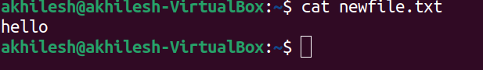

11. mkdir <dirname> 🡪 Creates a directory



12. mkdir -v <dirname> 🡪 Creates a directory and displays the status



13 . mkdir -p <dirname/dirname2> 🡪 Creates a directory within a directory

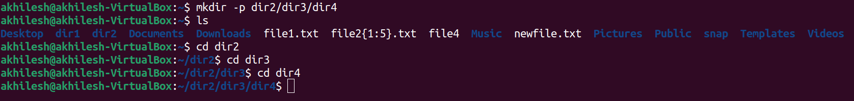

14. rm <filename> 🡪 To remove/delete a file



15. rmdir < dirname> 🡪 To remove/delete a directory



16. mv <filename> <newname> 🡪 To rename a file



17. mv <filename> <path> 🡪 To move a file from a directory to a specified directory

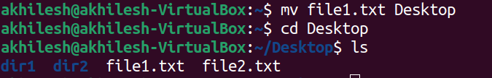

18. cp<source><destination> - To copy the content of file to a new/existing file

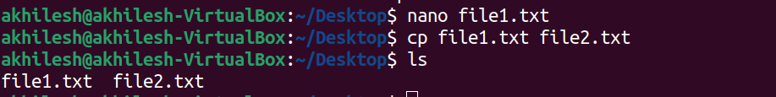

19. cp –v - Shows the execution details of command



20. cat–n – Shows the number with each line in a file

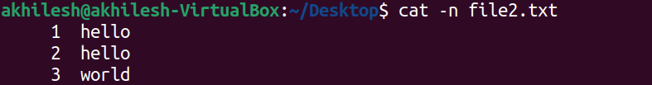

21. tac – Shows the content of a file in reverse order



22. cat <file1> >> file2 - displays the content of both files in file 2

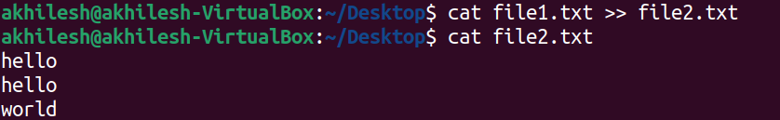

23. rm <filename> - used to delete a file from system

